Ruprecht-Karls Universität Heidelberg

Geographisches Institut

Berliner Straße 48

69120 Heidelberg

**Impact of a new minimum distance between wind turbines and settlements –**

GIS Analysis with free geodata

Course: **GIS Analyses with Free and Open-Source Software**  
Winterterm 2019/20

|  |  |
| --- | --- |
| Lecturer: | Christina Ludwig, M.Sc |
| Handed in by: | Group 5:   |  |  | | --- | --- | | Carsten Gawlas  Matrikelnumber: 3604077 | Ulrike Lorenz  Hauptstraße 21  69245 Bammental  Matrikelnumber: 3600484  Ulrike.Lorenz@stud.uni-heidelberg.de | |
|  |  |
| Heidelberg, den | 30.03.2020 |

**TABLE OF CONTENTS**

TABLE OF FIGURES 3

TABLE OF CHARTS 3

ABSTRACT 3

1 Introduction 4

2 Target/Hypothesis: 4

3 Location 4

4 Background 6

5 Data/Methods 8

5.1 Data 8

5.2 Methods 9

6 Results 10

7 Discussion 11

8 Outlook 11

9 Sources: 11

10 Declaration of Authorship 13

# TABLE OF FIGURES

Figure 1: Map of the research area 5

Figure 2: Elevation of the Research Area 6

Figure 3: Nameplate capacity of wind energy per year 7

Figure 4: Nettostromerzeugung in Deutschland in 2019 (Englisch) 7

Figure 5: Workflow 10

Figure 6: Result of the two distances 11

# TABLE OF CHARTS

Table 1: Comparision of the not available area regulated by minimum distances to infrastrucutre and settlements 12

**[Ggf. Abkürzungsverzeichnis]**

# ABSTRACT

# 

# Introduction

Germany works on the shift from fossil energies to renewable energies. This is even enshrined in German laws. The main part of the energy from renewable energies is wind energy. The state of Baden-Württemberg in southern Germany aims to get 10% of the needed energy out of wind energies produced within the state until 2020 (Windenergieerlass Baden-Württemberg 2012). In 2019 the German Government suggested a new law for Wind turbines. The proposal commands a new minimum distance of wind turbines from settlements. Even though the proposal is not yet implemented, it raised many questions on the impact of this law. These questions are, how much area will be affected by these new requirements? Will the new minimum distance have an impact in impeding the goals for 2020 for Baden-Württemberg?

# Target/Hypothesis:

To achieve the goal of more renewable energies it is necessary to find suitable places for new wind turbine parks. The target of this project is to calculate the total area, which is lost as potential locations for wind turbine parks by the new required distance to settlements. Is the new distance creating a big (significant) impact?

Furthermore the available areas will be evaluated and clipped by further relevant data like maximum slope, winddata and landuse. This will answer the Question: Which area/s is/are most suitable for a wind turbine park in the study area? This will also show if the new distance has a significant impact on the seize and geographical position of the most suitable area(s).

# Location

The research area consists of the Rhein-Neckar-Kreis and the Neckar-Odenwald-Kreis. The research area should be near the City of Heidelberg (see Figure 2: Map of the research area), which is located in the south-west of Germany, in the north of Baden-Württemberg. It is assumed that both the region of Mannheim and the region of Heidelberg are too small and the population density is too high, to be suitable for a wind turbine park. Because of that, the analysis for possible locations for wind turbines is performed within the regions of Rhein-Neckar-Kreis and Neckar-Odenwald-Kreis (see research area in Figure 2). The research expands over two main region (anderes Wort!!), this is the Oberrheingraben in the west, which has a really low Elevation (see Figure 3) and nearly no slope. In contrast to that is the other main Region (anderes Wort!), the Odenwald. The Odenwald is in the north and north-west of the Region. This mounatian region is much higher and has a heterogenic surface, with peaks and valleys, so the Slope is much higher. That means the reasch area consist of two really diffenent areas, one really flat and dominated by agriculture (Beweis einfügen!!) and the other one really hilly.

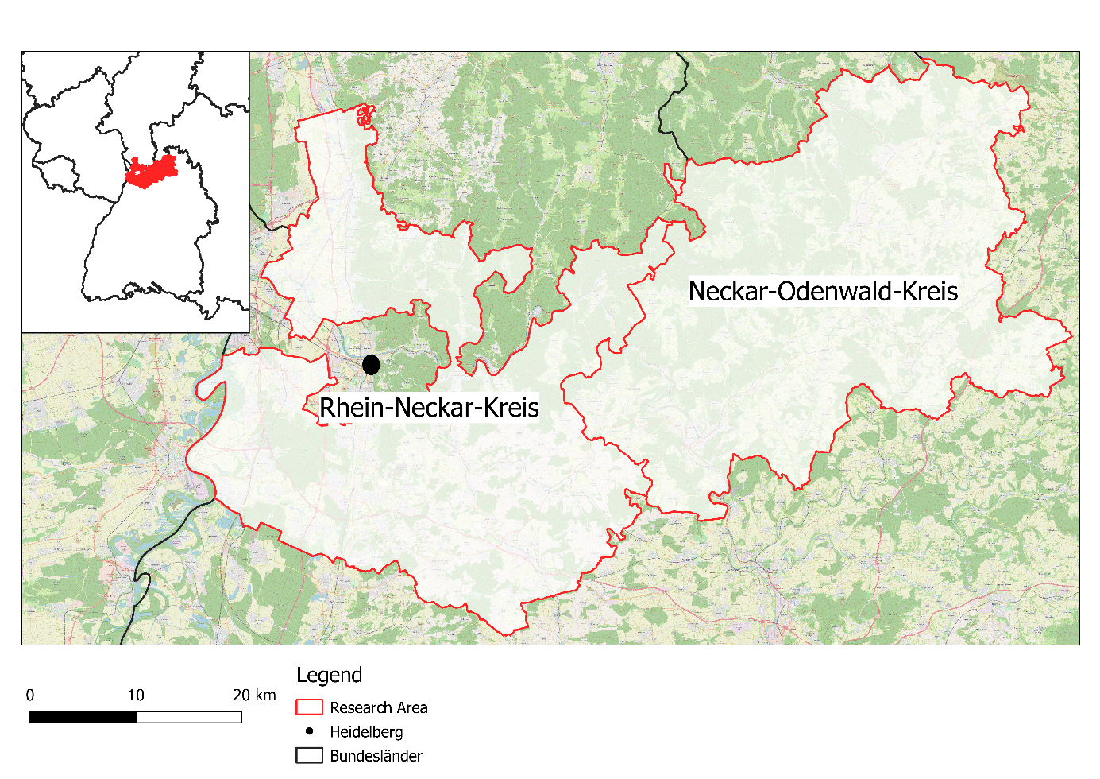

Figure 1: Map of the research area

Source: own map (Datengrundlage?)

Ein Bild, das Text, Karte enthält.

Figure 2: Elevation of the Research Area

Source: own map

# Background

In Germany 127,22 TWh, which is 24,6% of the electricity, was produced from wind energy in 2019. This means that wind energy is the biggest energy source in Germany (Figure 3). The production growth from 2018 to 2019 was nearly 16%. From the total wind energy is divided in offshore and onshore wind energy. The onshore wind turbines produced in 2019 102,6 TWh, so they are much more important at the moment than the offshore turbines (Fraunhofer ISE 2020a: 5).

A big Problem is the fluctuation in the amount of energy gained from wind. In Germany the gained energy from wind, changes on a daily to montly basis. For example in 2019 the amount of energy change from 18 TW/h in March to 6 TW/h in August (Fraunhofer ISE 2020a: 28). The main problem is, that the build-up of wind energy is decreasing (see Figure 3). Specially the nameplate of onshore wind energy. ……..

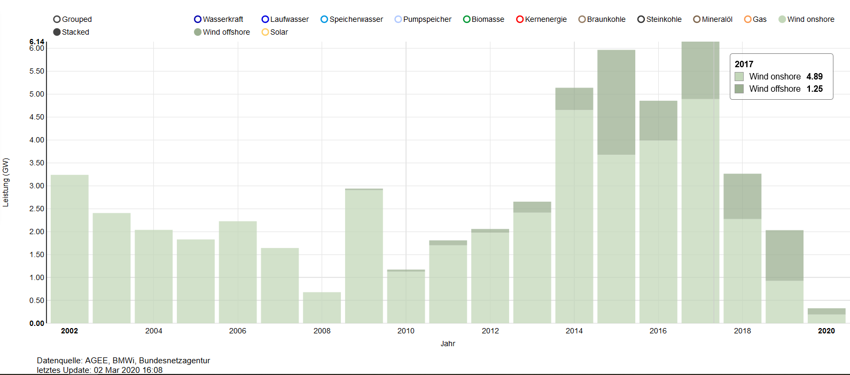

Figure 3: Nameplate capacity of wind energy per year

Source: Fraunhofer ISE 2020b

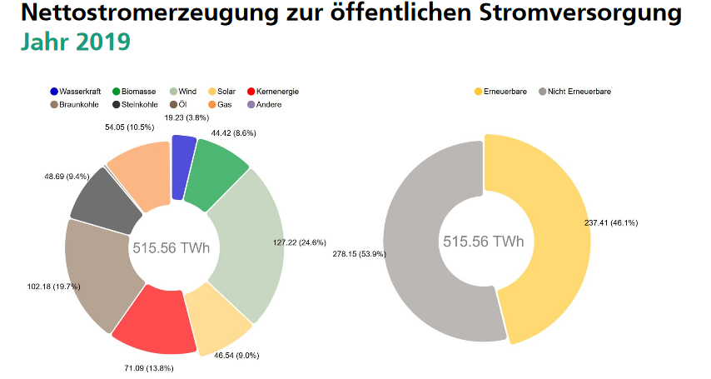

Figure 4: Nettostromerzeugung in Deutschland in 2019 (Englisch)

Source: Fraunhofer ISE 2020a: 13

For finding suitable areas the must be considered many different Criteria, the most important criteria to find a suitable location for a wind turbine park are the wind speed and the profitability considering the energy the park can produce and the coast of building and operation services. Criteria are divided in two groups: knock-out criteria and trade-off criteria. Knock-out criteria consider any form of settlement, traffic areas, energy pipelines/cables, radio stations, military stations, airports (no matter which size), nature and landscape aspects, waterbodies, some sorts of forest (protected, to use for relaxation or soil protection) and areas where natural resources are exploited. Trade-off criteria consider also nature and landscape aspects, regional important relaxation areas and cultural and soil landmarks (Gesellschaft für Landmanagement und Umwelt mbh 2013). For many of these criteria a certain distance to wind turbine parks is necessary as proposed in Bergmann and Höfle (2013).

# Data/Methods

The potential of free geodata in comparison with official geodata was investigated by Bergmann & Höfle (2013). They conclude that the free geodata are not as exact as official data, but the spatial location is nearly identical. In their conclusion free geodata can be used, to detect areas with potential locations for wind turbines.

To determine potential location, different parameters must be considered. This is the optical impact of wind turbines, which was analysed in a GIS-based approach by Taeger & Ulferts (2017). A different parameter is noise, but with a distance of 1000m noise surveys are no longer necessary (Lechleitner & Bohm 2016).

## Data

In this project free geodata, like OpenStreetMap will be used. The reasons for using free Geodata is, that it is free, easier to access and has already been used in analysis of potential wind turbines location (Bergmann & Höfle 2013). Within that study several tags are used to get the useful data, which will be adapted to our study and used in this analysis too. The following tags should be used for the analysis: landuse=residential/ farmyards/ industrial/ commercial, railway, aeroway=runway/ taxiway/ terminal, power=line/ minor_line, boundary=protected_area, leisure=nature_reserve, highway=motorway/ motorway_link/ trunk/ trunk_link/ primary/ primary_link/ secondary/ tertiary (Bergmann & Höfle 2013, adapted).

For the regions either OSM data (boundary=administrative (admin_level=8)) or other data sources (e.g. https://gadm.org/download_country_v3.html) can be used.

To get the best results both data should be downloaded and compared to find which one suits best for the analysis and to get an impression of the OSM data.

For the analysis is an elevation model necessary, free data is provided by several sources. The main difference is the spatial resolution. Because of the pretty small regions that are considered in this project, a high spatial resolution is necessary. This can be found at <https://www.opendem.info/download_srtm.html>.

Winddata con be found from several sources too. The most reliable sources for this project are the “Windatlas Baden-Württemberg” (<https://www.energieatlas-bw.de/wind/windatlas>) and the german weather service (which gives even more data by predictions for the future)( https://www.dwd.de/DE/leistungen/quwind100/qu-wind_100.html).

## Methods

The analysis will mostly be done within QGIS. Depending on the datasets a preprocessing can be done with help of GDAL. The data can either be downloaded by hand or can be downloaded by an automated script containing the OSM tags.

Every dataset must be buffered with the distance that is required according to German law. To see the difference that results from the new proposed distance to settlements, that layer must be buffered twice: With a buffer distance of 1000 m and a buffer distance of 700 m. All buffer layers must be merged and clipped with the administrative areas of the two regions to see possible areas for wind turbine parks and if the areas change depending on the new distance to settlements. For the possible areas an elevation analysis is needed to see if the areas are flat enough to build a wind turbine park on them.

Dolinski et al. (2012) propose an analysis with commercial programmes, but most of the analysis can also be done with QGIS. But also a script for GRASS GIS can be used to analyse the parameters for the potential wind turbine location (Bergmann & Höfle 2013). Using free software and data allows the repetition of this analysis in different areas.

The input data must be weighted according to their importance. The most important data to find the most suitable area for a wind turbine park is of course the wind itself. If there is no wind or too little in the height of the wind turbine (about 150-200 m above the ground) no wind turbine park would make sense. But even if there is wind it should not be too windy too because otherwise the wind turbine park has to be shut down when wind speed is too high so the gained energy would be less. On top of that the elevation and slope should be considered. Both are important factors because if an available area is in a valley it does not make sense to built a wind turbine park there. The slope can be a knock-out-criteria too, because only small slope values are allowed. High slope values would mean that the area contains a hillside which means that the wind park would contain wind turbines on lower sites which would produce less energy. That’s why the elevation should preferably be more or less evenly distributed, but should at least not have big differences. The last dataset that is really important is landuse data. This dataset contains some knock-out criteria too. The landuse is partly already included in the analysis (like settlements are already considered), but for example a big lake or river within a possible available area would make that area less attractive.

To work together on the project a GitHub repository is used (<https://github.com/UlrikeLorenz/Final_Project_Group5>).

This analysis has as usual some limitations. First of all is the fact that the analysis gives a hint which areas are suitable, but the results are not compulsory. The communities decide where a wind turbine park should be built or not. For many communities in Germany possible areas for wind turbine parks are already marked in the obligatory plans (like for example Flächennutzungsplan).

Another problem is the fact that some data could not be included in the analysis because it is simply not available. This includes data about vegetation and animals in the possibly available areas. That data is actually a important knock-out criteria for some areas, but often not analyzed before concrete plans for a specific area are made. Some habitats are even protected by german or European law, but now all protected areas are available as dataset, especially in more rural regions, so this could not be considered too.

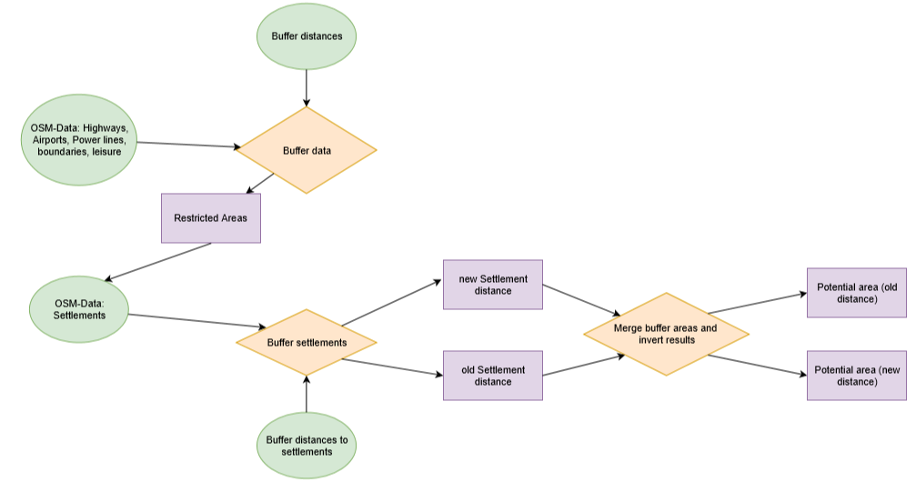

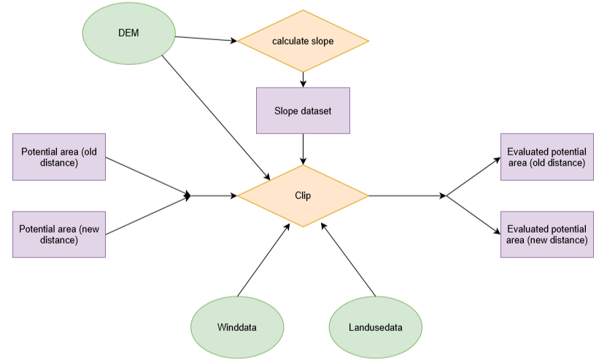

Figure 5: Workflow

Source: own

# Results

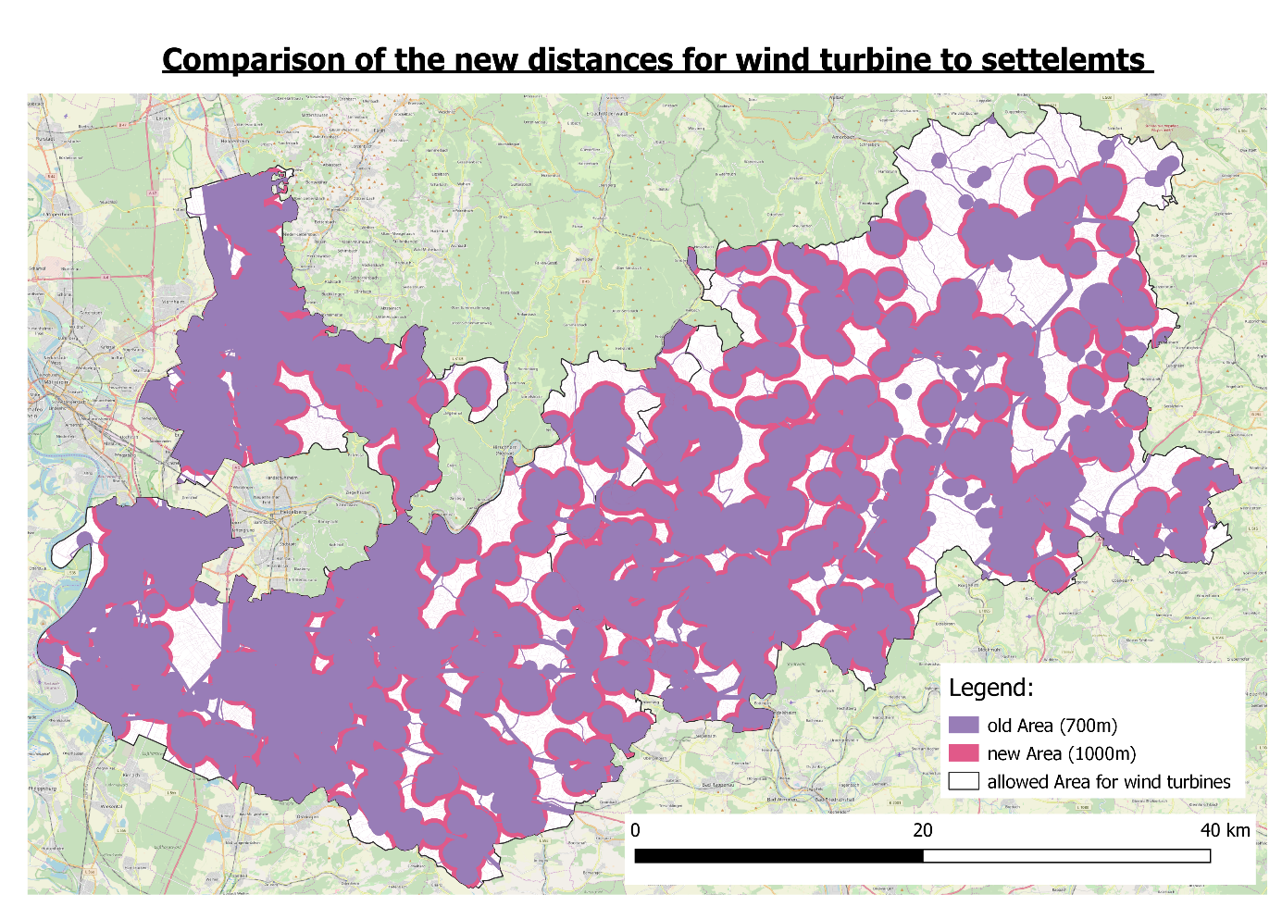

Figure 6: Result of the two distances

Source: own figure

First of all the area of both layers that is not available is counted to calculate the difference. This is done with the statistics tool. To do so the results are first warped to UTM, to get reliable results. This gives the following table:

Table 1: Comparision of the not available area regulated by minimum distances to infrastrucutre and settlements

Source: own figure

|  |  |  |
| --- | --- | --- |
|  |  | Difference: |
| Not available Area according to the old distance to settlements | 1460894414,7458239 m2 | 249359529,0609581 m2  (249,3595290609581 km2) |
| Not available Area according to the new distance to settlements | 1710253943,806782 m2 | Overall area (both Rhein-Neckar-Kreis and Neckar-Odenwald-Kreis):  2186176586,145 m2 |

This shows that the overall impact is significant. More than 10% of the overall area are no longer available for a wind turbine park when using the new distance to settlements.

# Discussion

* Actually processing with GRASS GIS was planned but:
  + *Difficulties because of several projections*
  + *Problems while buffering*
  + *Import of Winddata was not possible (Dataformat NetCDF)*
  + *Union not possible because of data structure (attributes got lost under processing)*
* Political process, not everything caused by spatial information
* Landuse-Layer aus OSM hat Löcher, wird daher ersetzt durch CORINE Landcover von Copernicus
* Main problem are protests

# Outlook

* Add Minimum area
* Using DEM (maximum slope)
* Using wind data
* Perform precise analysis of our result

# Sources:

Fraunhofer-Institut für Solare Energiesysteme (ISE) (2020a): Öffentliche Nettostromerzeugung in Deutschland im Jahr 2019. https://www.energy-charts.de/downloads/Stromerzeugung_2019_3.pdf (last accessed 04.03.2020).

Fraunhofer-Institut für Solare Energiesysteme (ISE) (2020b): <https://www.energy-charts.de/power_inst_de.htm?year=all&period=annual&type=inc_dec> (last accessed 05.03.2020)

Bergmann, M. & Höfle, B. (2013): GIS-gestützte Standortplanung von Windenergieanlagen mit freien und amtlichen Geodaten. In: Strobl, J., Blaschke, T., Griesebner, G. & Zagel, B. (Hrsg.) (2013): Angewandte Geoinformatik 2013. Berlin/Offenbach (Herbert Wichmann Verlag / VDE Verlag GMBH).

Dolinski, J., Schönewolf, J. L. & Dall, K. E. (2012): GIS-Modul: Digitale Kartengrundlage zur Eignung von Windenergiestandorten. In: Bachmann, E. M., Buning, M., Cislaghi, L., Dall, K. E., Diehl, I., Dietrich, F., Dolinski, J., Fischer, K., Geier, M., Gohn, C., Grün, W., Ilgner, F., Kiehl, S., Keller, M., Leba, M., Mathdorff, S., Richardt, L. K., Schnorr, M., Schuster, C., Schönewolf, J. L., Seif, J. V., Weigang, A., Prof. Dr. Diller, D., Dipl. Ing. Prof. Luterbacher, J., Ph.D. Dr. Erb, W.-D., Dipl. Geogr. Hoffmann, A. (2012): Projektbericht Regionalplanung und Klimawandel. Gießen: Institut für Geographie Gießen Klimatologie und Kommunale und Regionale Planung.

Gesellschaft für Landmanagement und Umwelt mbh (2013): Standortanalyse für Windkraftanlagen zur Ausweisung von Konzentrationszonen für die Stadt Neustadt an der Aisch Westmittelfranken Bayern. Erläuterungsbericht. Weikersheim (Klärle).

WINDENERGIEERLASS BADEN-WÜRTTEMBERG (2012): Gemeinsame Verwaltungsvorschrift des Ministeriums für Umwelt, Klima und Energiewirtschaft, des Ministerium für Ländlichen Raum und Verbraucherschutz, des Ministeriums für Verkehr und Infrastruktur und das Ministerium für Finanzen und Wirtschaft. http://gewerbeaufsicht.baden-wuerttemberg.de/servlet/is/37557/Windenergieerlass_-_Ausser_Kraft_seit_09-Mai-2019.pdf (last accessed 26.11.2019).

Lechleitner, M., & Bohm, R. (2016). Kann durch Landesrecht ein Mindestabstand zwischen Windkraftanlagen und Wohngebäuden festgesetzt werden? (Wahlperiode Brandenburg, 6/21). Potsdam: Landtag Brandenburg, Parlamentarischer Beratungsdienst.

Taeger, S., & Ulferts, L. (2017). Von Windparks umzingelt - oder nicht?‒ ein GIS-gestützter Ansatz zur Ermittlung der optisch bedrängenden Wirkung von Windenergieanlagen im Zuge der Regionalplanung. AGIT Journal, 3, 130-141.

Wieduwilt, P. D. (2018): Ein GIS-gestütztes Bewertungsverfahren zur Beurteilung des Beeinträchtigungspotenzials von Windenergieanlagen auf landschaftsprägende Denkmäler und historische Kulturlandschaften. Freiberg: Technische Universität Bergakademie Freiberg Fakultät für Wirtschaftswissenschaften.

# Declaration of Authorship